Linear Programming Using PuLP and Introduction to Formulating Optimization Problems

What is Linear Programming?
Linear Programming (LP) is a mathematical technique used to find the optimal outcome (maximum or minimum) of a linear objective function, subject to a set of linear constraints. It is widely used in operations research, business, and engineering for resource optimization.

Why is Linear Programming Important?
- Efficiency: Helps optimize limited resources like time, materials, or money.
- Practicality: Used in real-world scenarios such as production planning, transportation, and portfolio management.
- Simplicity: Linear relationships make the problems easier to solve computationally.

When is Linear Programming Used?
Linear programming is applied when:
- The objective function and constraints are linear.
- You need to maximize or minimize an objective (e.g., profit, cost, resource utilization).
- There are multiple constraints limiting the decision variables (e.g., resource limits).

Where is Linear Programming Applied?
- Business: Maximize profit or minimize costs.
- Manufacturing: Optimize production schedules.
- Transportation: Minimize shipping costs.
- Finance: Portfolio optimization.

How Does Linear Programming Work?
- Define the Objective Function: The function to maximize or minimize.
  - Example: Maximize total revenue
- Identify Decision Variables: Variables that affect the outcome.
  - Example:
- Formulate Constraints: Linear inequalities that limit the decision variables.
  - Example: Resource limits for apples, mangoes, and cherries:
- Solve Using Optimization Software:
  - Use tools like PuLP in Python to define and solve the problem.
  - Example PuLP steps:
    - Define the problem using LpProblem().
    - Create decision variables using LpVariable().
    - Add constraints and the objective function.
    - Solve the problem using lp.solve().

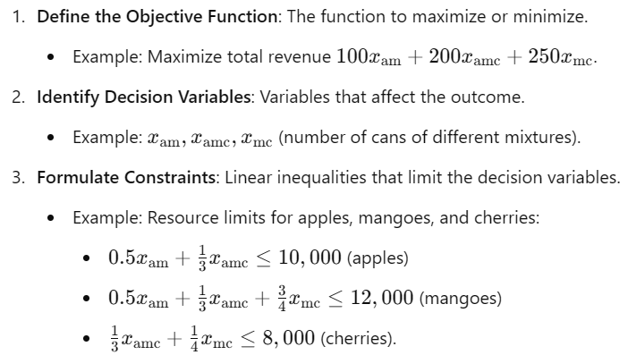

Example Solved:
In the example, the goal was to maximize revenue for producing three canned fruit mixtures:
- Mixture 1 (xam​): Apple and mango.
- Mixture 2 (xamc): Apple, mango, and cherry.
- Mixture 3 (xmc​): Mango and cherry.
Solution:
- Produce 18,000 cans of Mixture 2 and 8,000 cans of Mixture 3.
- Do not produce Mixture 1 due to lower profitability and resource constraints.
- Maximum revenue achieved: ₹5,600,000.

Advantages of Linear Programming with PuLP:
- Ease of Use: PuLP provides a Python-based interface to define and solve LP problems.
- Flexibility: Handles a wide variety of constraints and objectives.
- Integration: Interfaces with solvers like CBC, Gurobi, or CPLEX for high-performance optimization.

Summary (What, Why, When, Where, How):
- What: A technique for optimizing resources under constraints.
- Why: To maximize outcomes like profit or minimize costs.
- When: When objective functions and constraints are linear.
- Where: Business, manufacturing, transportation, and finance.
- How: Formulate the problem, define variables and constraints, and solve using tools like PuLP.

